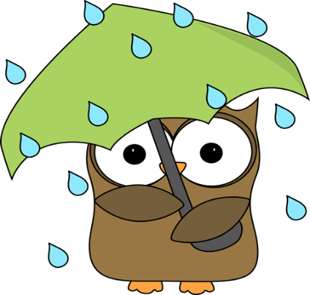
This Photo by Unknown Author is licensed under CC BY-NC-SA
We ALL Have Bad Days.

Take a breath and make a good choice:
- Use class procedures to avoid inappropriate behavior.
- Stay on task and demonstrate effort.
- Respect yourself and others.
- Follow all school and county policies.

In life, there are consequences if we don’t get it together:
- Student receives a non-verbal cue to refocus.
- Student receives a verbal or written notice to clarify.
- Mrs. Waller will do something.
- Student’s parent/guardian will be notified.
- Student will meet with Mrs. Waller after school.
- Student will meet with guidance and/or administrators.

